Puppet Pals Refresher- Storytelling App
Puppet Pals is a creative app that helps you design animated cartoons. It is simple and can be used in projects in various subject areas. You could use this engaging app to practice a second language, to be a tour guide of a city, to explain a recipe, to share your favorite book, to give instructions, etc. The possibilities are endless.

1.Think about your setting and plan your scenario. Make a storyboard.  (intro, development, climax, resolution) | 2. On the iPad, open the Puppet Pals 2 App. | 3. Select play. | 4. Select a location for your story. You can even take your own picture.  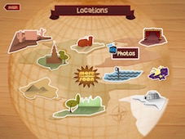
In this screen, if you  select  you can take a photo or choose a photo in your camera roll. | If you want a picture that you find on the Internet  1. Open a browser in a different window  2. Find a picture  3. Press the power and home button at the same time. This will add the picture to your camera roll on the iPad.  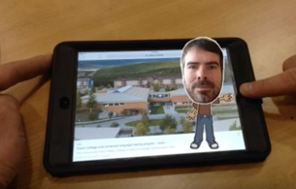 | 5. Icons at the top left will help you add vehicles, characters and music to your set. | The 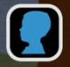 button lets you add face from a picture.  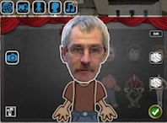
6. When your scene is ready and the characters are in place press the red button at the top right to start recording.  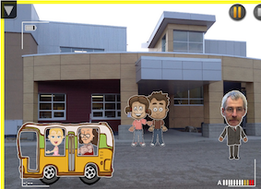 | 7. You can pause your play and switch scenes and continue recording by selecting the globe icon. | 8.To save press to restart press .  To access your videos press the globe icon and the main arrow, this will bring you back to the main page. 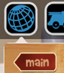 | 9. From the main Puppet Pals page press 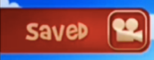  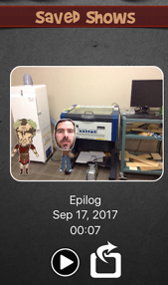
10. Press this icon  to export your video.  You can save, airdrop and email your video. | Tips - On the main Puppet Pals page, go to  and turn the background music off. | Tips - If you need to create a video that has multiple scenes and is long, save your video in multiple files and import them in the iMovie app.  In iMovie, you can change the order of scenes, add music, cut the end of scenes, ...
Michel Emery - FH Collins Learning Commons - Sept 17, 2017

