Laser Cutting - Preparing your project

To create a great looking product, you will need to spend some time adjusting and refining your drawing. You will also need to take into consideration the materials you are working with. Here are some useful tips.
- Dark and well traced lines work well  - You will get better results using a scanner or you can take a picture  - if you take a picture, make sure there is plenty of lighting | -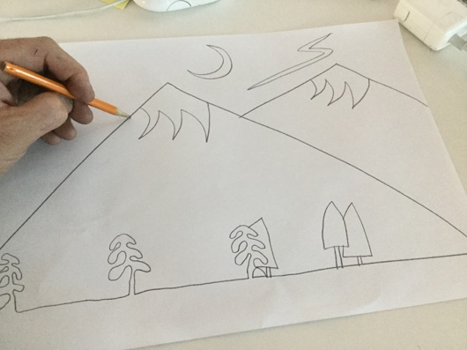
When you click your picture on your Mac, the application "Preview" 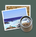 will open. Preview has some useful tools when you click on the markup toolbox. | 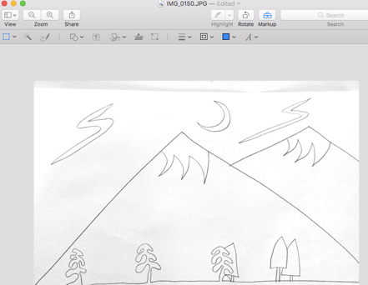
The tools I use the most are the selection tool as well as the adjust color tool . Adjust color is very helpful to fine tune the tones in your image. You can make your image black and white, and even instantly remove faint pencil marks using the exposure and contrast sliders. | 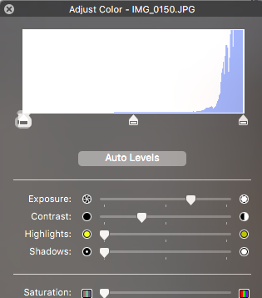
Open Adobe Illustrator  If you don't have Adobe Illustrator, you can install it from the self-serve on the computer. | In adobe, go to "File" & "Place" to place your image on your canvas. If you wish to keep the same proportions when sizing, press the shift key at the same time as you drag your mouse.  Remember 18 x 12 inches is the max.
Photos
If you import your drawing/scan in Photos , there are some great features you can use. You can laser etch a photo from your computer onto materials. A color photo might not laser well. You might need to adjust the contrast and sharpness to accentuate the details.
In Photos, File import. Once you see your picture, click on this symbol in the top right corner.  Filters and Adjust are the tools I use the most. | 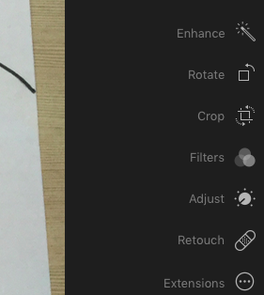

Adobe Photoshop Elements Editor
In Adobe Photoshop Elements Editor, you can edit your image in multiple ways. I like to use to select specific areas of my drawing and the to fill them in with a solid color. | 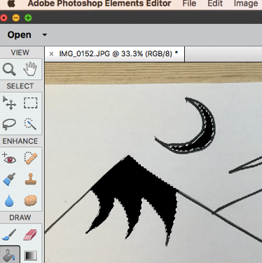

Adobe Illustrator
In Adobe Illustrator, | With you can draw/ add details on your image. Start by selecting the color and stroke width.  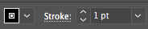
You need to play with the useful "image trace" tool. You can try different options to see the effect on your drawing. This feature converts your drawing into lines which you can then change the size or even vector cut.  Once done, click on 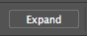 to see your lines.  This is useful if you want to cut out the outline of a drawing. Set the line you wish cut to .001. | 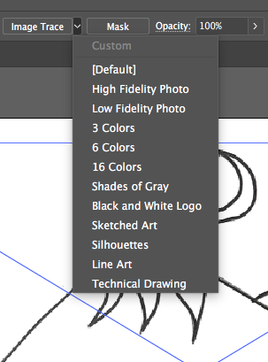
A great tool is the text tool. If you press shift and click on the , you will see more options such as . You can draw any shape or line and have the font follow this line. | 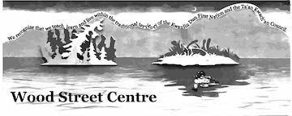
Some fonts on your own computer might not be available on the computer connected to the laser cutter. I often use "georgia" font which is present on both computers or just change the font when you open your file.

These were my top tips.
Cheers
Michel

