Taking Care of Myself, Taking Care of Others
Health and Safety in the Classroom Grades 4-9

Development:
Nikki Krocker, Curriculum and Assessment, Yukon Education

Contributors:
Flora Asp, First Nations Initiatives, Yukon Education
Natalie Thivierge, Yukon Workers’ Compensation Health and Safety Board
Sharon Davis, Student Support Services, Yukon Education
Âkw Tlâ Tammy Stoneman, First Nations Initiatives, Yukon Education
Vanessa Stewart, Yukon Workers’ Compensation Health and Safety Board

Introduction

The Chief Medical Officer of Health in collaboration with the Department of Education has developed guidelines for K-12 school settings that will help teachers, administrative staff, students and families prepare for a safe return to school. The information provided below is subject to change as the local and national epidemiology of COVID-19 evolves.

Rationale

COVID-19 and children and youth
- The COVID-19 virus has a very low infection rate in children and youth. In larger jurisdictions, like British Columbia, less than 1% of tested children and youth have been COVID-19 positive. Most children and youth are not at high risk for COVID-19 infection.
- Children and youth typically have much milder symptoms of COVID-19 most often presenting with low-grade fever and a dry cough.
- There is no conclusive evidence that children who are symptomatic pose a risk to other children or to adults.
- Evidence indicates transmission involving children is primarily limited to household settings and from COVID-19 positive adults to children.
- Clusters and outbreaks involving children and youth are unusual and tend only to occur in areas where there are high levels of community spread.
- Children are not the primary drivers of COVID-19 spread in schools or in community settings.
- Schools and childcare facility closures have significant negative mental health and socioeconomic impacts on vulnerable children and youth.
- Prevention measures and mitigation strategies involving children and youth must be commensurate with risk.

Connections to Yukon First Nations Ways of Knowing, Doing and Being

Understanding our responsibility to take care of ourselves because we respect ourselves is one of the opportunities provided in this lesson. When we take care of ourselves through activities like hand washing and staying a safe distance apart, we are taking care of those around us. This shows respect for people in our Family, our Elders and community. When we take care of ourselves, we take care of others.

Big Ideas
- Healthy choices influence our physical, emotional, and mental well-being. (Physical and Health Education Grades 4-9).
- Data from graphs can be used to illustrate, compare and interpret. (Mathematics Grade 4-9)

Core Competencies

- Personal Awareness and Responsibility - Well-being
- Social Awareness and Responsibility: Building relationships

Resources

Document on Social Emotional Support for the Return to School from Student Support Services

Health and Safety Guidelines for K-12 School Setting

Finding Our way through a Pandemic by Marilyn Jensen – Yadultin, Dahkla’weidi Clan, 2020
https://www.ctfn.ca/news-events/finding-our-way-through-a-pandemic

Two Huskies Apart Poster:
https://yukon.ca/en/two-huskies-apart-proper-physical-distancing

Yukon Government Hand Washing Sign:
https://yukon.ca/sites/yukon.ca/files/hss/hss-imgs/covid_handwashing_web.pdf

Planning to Teach

As teachers, you know yourself and your students the best. Should you find something that is more applicable to your classroom please modify any aspects of this lesson to fit the culture and context of your classroom of students.

Teacher Well-being

In order to teach about health and safety you need to feel healthy and safe. While we are all doing our best, it is important to remember some simple things for ourselves and for our students as we go back to in person learning:
- Getting a good night’s sleep. One of the best ways to prepare yourself for a classroom full of excited students is to be well rested. It is easy to put ourselves as teachers last and now we need to think of ourselves first and how we can keep ourselves healthy and calm so we can be there for our student during this difficult and ever-changing time.
- Eating well.
- Being active and outside as much as possible. On your own and with your students!
- Creating a classroom space for yourself and your students that feels safe and relaxed.
- Connecting to two people at the school you can go to for support.

Review the “Document on Social Emotional Support for the Return to School”.

Watch the session on “Regulation Before Education”, by Syrena Oswald. In her session she discussed how in order to teach students both the teachers and students need to feel safe and regulated. There are many ideas and links to other resources to help teachers as well as tools to assist students with developing these skills. The link to her slides can be found at:
http://msnider.yukonschools.ca/june-10-2020.html

Resources

Pandemics & Infodemics - Wisdom In The Time Of Covid-19 | Russell Brand & Dr. Gabor Mate
https://youtu.be/7FEoQOurpGo

Become Awake Now! | Eckhart Tolle & Russell Brand
https://www.youtube.com/watch?v=6EwzvKF-o_Y

Learning Activity 1: What is Coronavirus and How is it Spread?

Video: Coronavirus Explained! (for kids)

This video gives a brief explanation of what the Coronavirus is and how it affects the body.
Find it at:
https://youtu.be/OPsY-jLqaXM

Activity: Socially Distanced Air High Five!
Students participate in an activity where they can see how quickly germs such as the Coronavirus can be spread in a small group of people. Explain to students that normally this would be done as a “high five” activity with everyone clapping one another’s hands. In order to reduce the spread of germs we will play it using socially distanced air high fives instead of clapping high fives. Students will be able to see how if we were high fiving and touching, how easily germs can be passed from one person to another.

For this activity you will need:
- Post-it notes
- Vinyl gloves

Play the high five virus game:
  - Give students a post-it note each. Include yourself in this activity. Give gloves to a few students.
  - Ask all student to move around and air high five with at least 5 peers and jot down their names.
  - Once everyone has air high fived, have them sit down.
  - Tell the students that you have the High Five Virus. Whoever had air high fives, got the virus except for those that wore a glove. People who socially distanced air high fives, maybe have also gotten the virus. The virus may have even spread to the whole classroom (except those with gloves) if everyone air high fived someone who was infected. Note: if the group size is small, change the number of socially distanced air high fives to just 3 other people.
  - Tell students that germs and bacteria are all around us, which we spread through touching things and even just through breathing. Once these germs are on our hands and we touch our face, nose and eyes, or food that we put into our mouths, the germs get into our bodies and can make us sick.

Video: See How Germs Spread
This short video shows how germs can be spread in a classroom setting and talks about some of the ways we can all reduce the amount of germs that we share. Watch from 0:00 to 8:30.
Find it at:
https://youtu.be/I5-dI74zxPg

Activity: Food for Thought

The following activity is adapted from Yukon Workers’ Compensation Health and Safety Board’s “Stop, Think, Do!” lessons on p. 88. You can find the resource at:
https://www.wcb.yk.ca/getattachment/LearnSafe/ResourceKits/LearnSafeResKit3-5.pdf.aspx)

Purpose: Why should I clean my hands before eating? How can I clean my hands properly to stay healthy?

Assessment objectives/intentions: What counts?

Students will be able to describe when and how to properly clean hands.

Material Required:
- Flour
- Cooking Oil
- Cinnamon
- Washing tubs or sink
- Warm and cold water
- Hand soap

Teaching Strategies:

- When do we need to be thinking about washing our hands? Brainstorm as a class. Examples include cooks, doctors, vets, dentists, painters, scientists, or just about anyone who works with the public or messy materials. We will be talking about some of the dangers of not cleaning our hands, as well as how to clean our hands properly to keep from getting sick.

- Why do we need to wash our hands before eating? Think, pair with a partner and share as a class. What are microbes, like bacteria and viruses? Where are they? How do you think germs get around? Answers may include: Bacteria are so tiny that you need a microscope to see them; some bacteria can make you sick so it’s a good idea to avoid dangerous bacteria all around us; they can be in food (a sick person contaminates food that is then eaten by another person); they can move from one person to another; they can move on the food itself as it moves from the farm through the grocery store and to our homes.

- Let’s do an experiment to see how microbes can travel quickly around the class. Have a volunteer put some flour on his hands. Ask them to open the class room door, sharpen a pencil, and take a book from the class library. What do you notice about how the flour has spread? How is the flour like microbes or viruses? Can we see the germs when we touch things in the class or touch each other’s hands?

- What can we do to prevent germs from getting into our bodies when we touch the food that we eat? Ask three volunteers to demonstrate the experiment.

  - Ask all three to rub a spoonful of cooking oil all over their hands. Sprinkle cinnamon onto their hands and rub it around. What does the cinnamon represent? How do we get it off?
  - Wash hands as follows, rubbing them briskly for 20 seconds:
    - Student #1: wash hands with cold water and no soap
    - Student #2: wash hands with warm water and no soap
    - Student #3: wash hands with warm water and soap
    - The rest of the class observes the different hand washing methods or, if you have space and time, have all students experiment in small groups.

- Based on this experiment what is the best way to wash your hands? How do we know? Brainstorm as a class and note ideas on the board. Make sure to include the following ideas:
  - Use soap and warm water.
  - Wash for at least 20 seconds (or long enough to sing a short, familiar song like “Happy Birthday”).
  - Cover your palms, the back of your hands, and in between your fingers with suds.
  - Make a good sudsy lather, and get underneath fingernails and in between fingers.
  - Rub and scrub! It’s the suds and the friction that kill germs.
  - Dry with a disposable paper towel.

- Ask the students “When do we need to wash our hands?” Brainstorm answers on chart paper you will keep in the classroom. Make sure to add any of the others from the list below that may have been missed.

When students should wash their hands | When staff should wash their hands
- Before and after any transitions within the school setting (e.g. to another classroom, indoor-outdoor transitions)  - Whenever hands are visibly dirty  - After using the washroom  - Before and after eating and drinking  - After sneezing or coughing into hands  - After playing outside | - Before and after any transitions within the school setting (e.g. to another classroom, indoor-outdoor transitions)  - Whenever hands are visibly dirty  - After using the washroom  - Before eating and drinking  - After sneezing or coughing into hands  - Before handling food or assisting students with eating  - After contact with body fluids (i.e., runny noses, spit, vomit, blood)  - After cleaning tasks  - After removing gloves  - After handling garbage

- Challenge students make an instructional hand washing film strip for their families. Make sure students describe why we need to wash our hands, when to wash our hands and to show all steps of the proper washing technique. Assign students to present their filmstrip to their families as homework and ask for parent feedback on their presentation.

Curricular competencies and Content:

Healthy choices influence our physical, emotional, and mental well-being. (Physical and Health Education Grades 4-9).

Core Competencies:

Personal Awareness and Responsibility - Well-being

Students who are personally aware and responsible recognize the factors that affect their holistic wellness and take increasing responsibility for caring for themselves. They keep themselves healthy and stay active, manage stress, and express a sense of personal well-being. They make choices that contribute to their safety in their communities, including their online communities and use of social media. They recognize their personal responsibility for their happiness and have strategies that help them find peace in challenging situations.

Discuss with students the Personal Awareness and Responsibility competency. Students can create posters, stories or a short video demonstrating their understanding of this core competency.

Other information:

What are the symptoms of COVID-19?
- Fever/chills
- Cough
- Shortness of breath
- Runny nose
- Sore throat
- Headache
- Loss of sense of taste or smell
- Fatigue
- Loss of appetite
- Nausea and vomiting
- Diarrhea
- Muscle aches

Learning Activity 2: Math Inquiry: Diving into Numbers

Share with students the graph on Age and the distribution of COVID-19 cases deceased in Canada as of July 27, 2020 from the Government of Canada

This graph can be found at:
https://health-infobase.canada.ca/covid-19/epidemiological-summary-covid-19-cases.html#a5

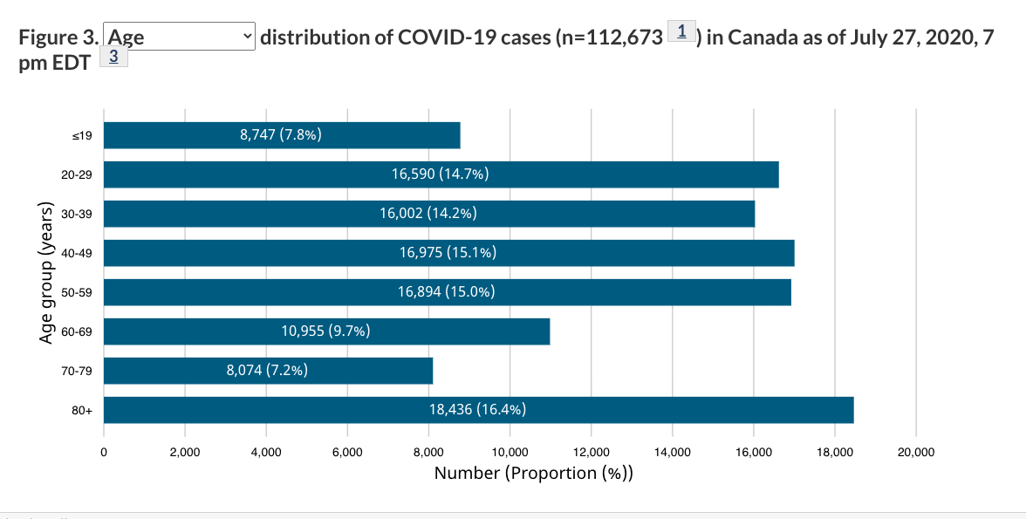

Have students discuss the following questions (add any others you can think of):
- What information is shown on this graph?
- What is this graph about?
- What story is this graph trying to convey?
- How can we use this information?
- Can we change this graph?
- How can our actions influence this graph?

Reading Activity: “Finding Our way through a Pandemic” by Marilyn Jensen

Share with students that Marilyn Jensen - Yadułtin is Inland Tlingit and Tagish Khwáan from the Carcross/Tagish First Nation. She belongs to Dakhl’aweidí Clan.

Share a photo of Marilyn from:
https://www.tourismvictoria.com/impact/speakers/impact-speaker-marilyn-jensen
https://pressbooks.bccampus.ca/echoyukonsfirstpeople/chapter/entertainment/

Read to students p. 2-3 (Beginning at Taking a Positive Approach on p. 2 to the list of teachings on p. 3) from “Finding Our way through a Pandemic” by Marilyn Jensen.

Ask students how they can connect the information and what they have learned from the graph with the teachings Marilyn listed in her story.

Extension - Loose Parts Activity: Invite students to collect Loose Parts. Students can build their own Loose Parts Kits to use in other activities through the year. Students can make connections between their lives, what they have learned in the graph about the virus and the teachings in Marilyn’s story. Students can use Loose Parts to answer some questions such as:
- How can I take care of myself and my community?
- How do I show Respect, Courage, or Compassion?
Have students arrange the Loose Parts on their mat. See photograph examples.

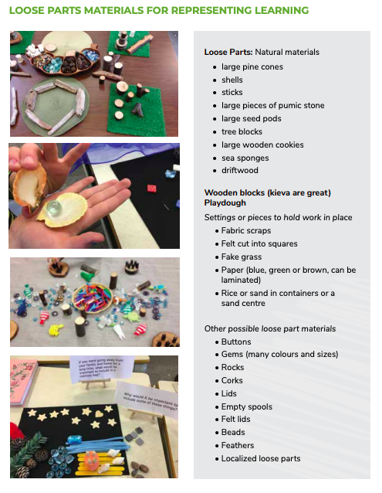

Curricular competencies and Content:
- Communicating and representing
  - Use mathematical vocabulary and language to contribute to mathematical discussions
- Connecting and Reflecting
  - Incorporate Yukon First Nations ways of Knowing, Doing and Being to make connections to mathematical concepts
  - Reflect on mathematical thinking
  - Use mathematical arguments to support personal choices
  - Explain and justify mathematical ideas and decisions

Core Competencies:

Social Awareness and Responsibility: Building relationships
Students build and maintain diverse, positive peer and intergenerational relationships. They are aware and respectful of others’ needs and feelings and share their own in appropriate ways. They adjust their words and actions to care for their relationships.

Brainstorm with students how they can show in the classroom, school, home and community how they can be respectful of others’ needs and feelings.

