3 D Printing – Quick Reference
Design & Prototype
1. Go to www.tinkercad.com |  | Create a Free Account
For some quick lessons select “Learn” on the top left corner.  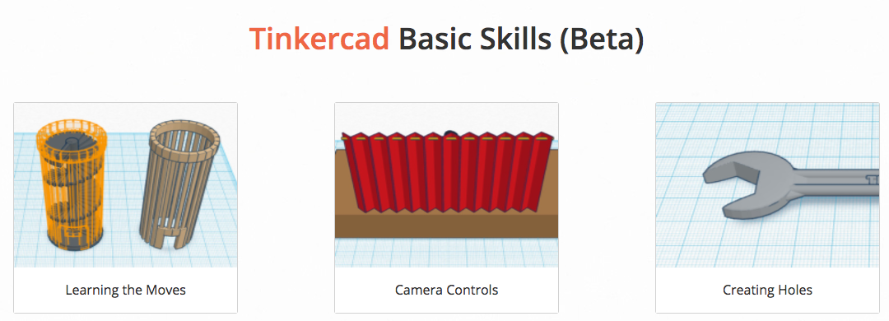 |  | Click on your avatar in the top right corner and  + New to start | 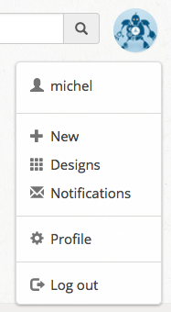 | Click on the strange name to rename your creation.  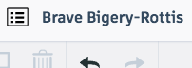
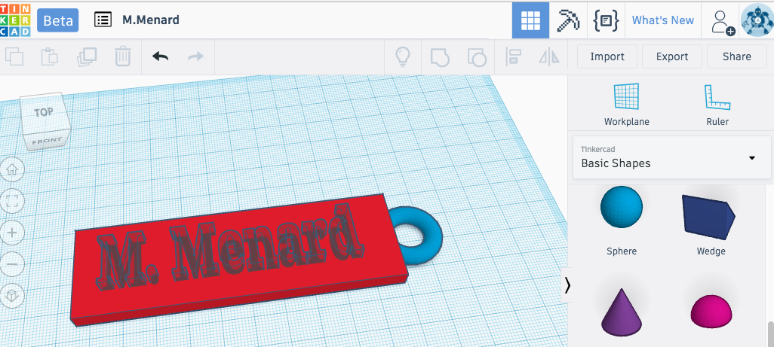  Use various solids to design your 3 D objects. Simply drag and drop. |  | Any shape can be  A solid 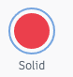or a hole 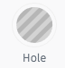  Measurements on the grid are in millimeters. The blue outline = 1cm or 10 mm |  | You can adjust the shape dimensions in this box or by clicking on the white squares on each shape.  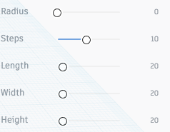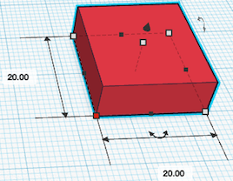
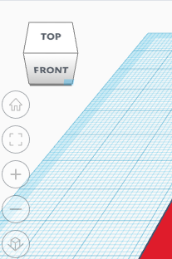 | Rotate the cube on the top left to see your objects from different angles | This toolbar is quite useful to align, group, ungroup, or flip objects.  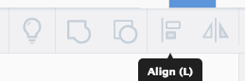 |  | When you are done, select | 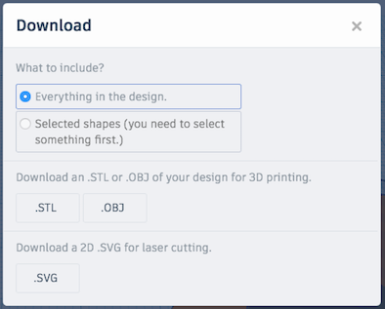  Select STL
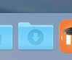 | A copy of your design will be saved in the downloads folder on the dock. | At this point, you will need the slicer software

Slice & Print
 |  | Download  a free copy | This will slice your design in steps the printer can understand.
Import your file from the downloads folder. | 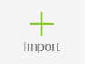 | You can make some adjustments which will affect the precision, density and print time.  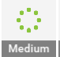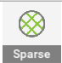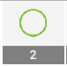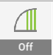and | When you are done, select 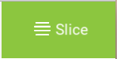
This will show you your print time and filament usage.  the + allows you to insert a pause during printing if you want to change color mid project. Save for print if you are ready. |  |  | If you are ready to print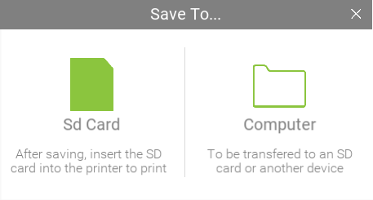
M.Emery FH Collins April 28, 2017
Take your SD card to the 3D printer and print your design.

Learn More
 |  | www.u.tinkerine.com
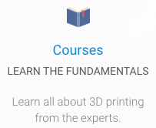 | 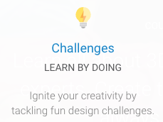 |  | 